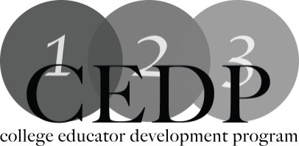

Assessment Design for Teaching - How to Improve Academic Honesty

Workshop Description:
Whether using traditional, blended, or online teaching methods, how you assess can differ. In this workshop, we will discuss assessment for different delivery methods and how to proactively increase academic honesty through the design of your tests and assignments.

Learning Outcomes:
1. Identify assessment types for face to face and online instruction.
2. Identify academic honesty issues associated with assessment and delivery modes.
3. Identify strategies to enhance academic honesty through the design of assessments.

Facilitators: Sue Prestedge, Mohawk College and Chris McCrory, Mohawk College

For more information: susan.prestedge@mohawkcollege.ca

Chris.mccrory@mohawkcollege.ca

Resources:
1.A useful site to use with students for the purposes of illustrating plagiarism:
http://www.plagiarism.org/
2.How to stimulate discussion about academic integrity in the classroom:
https://www.quinnipiac.edu/prebuilt/pdf/wac/database_fifty_ways_academic_integrity_0811.pdf
3.Definition of Plagiarism,what causes it and how to help students avoid it:
> http://honesty.uci.edu/AcademicHonestyTips.pdf

